Huntsville Skating Club

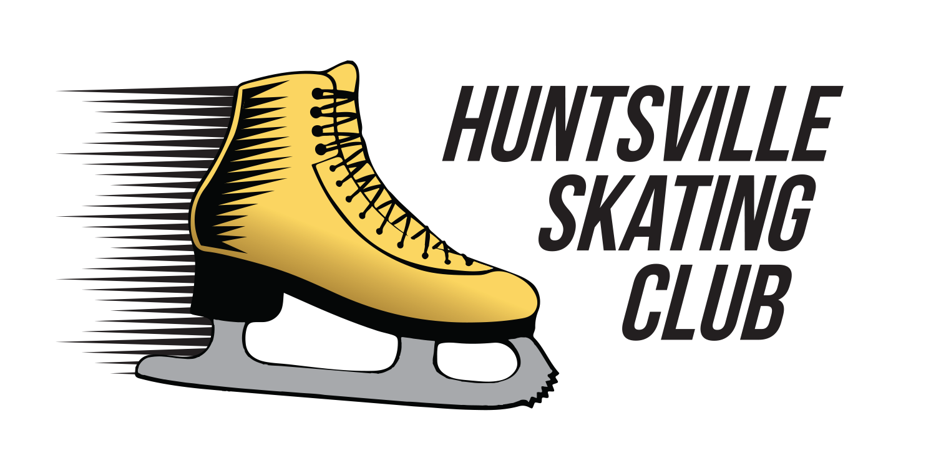

PreCanSkate, CanSkate and Power Skating Handbook
2017-2018

www.huntsvilleskatingclub.ca

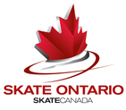

Huntsville Skating Club
Board of Directors
2017-2018

President: Kerri Vallentin
Vice President: Robin Brushey
Secretary: Michelle Breakenridge
Treasurer: Kellie Heap

Registrar: Ryan Vallentin
Publicity: Michelle Breakenridge
Fundraising: Michelle Breakenridge & Robin Brushey
CanSkate Liason: Muriel Blaker
Test Chair: Lisa Bjorkquist
Ice Scheduler: Kerri Vallentin
Volunteer Liaison: VACANT
Carnival Chair: Muriel Blaker
Coaches Liaison: Robin Brushey
Coaches Rep: Chrissy Mantle-Marnoch

Huntsville Skating Club Coaches

Christine Mantle-Marnoch
cmskate5000@gmail.com

Linda Vandertas
lindavandertas@live.ca

Tim White
soulim2009@hotmail.com

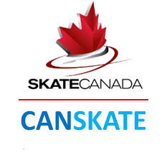

CanSkate is a dynamic learn-to-skate program designed for skaters of all ages and levels. Our Canskate program is designed for children as young as 3 years old.

The Canskate program focuses on the development of balance, control and agility. These skills are taught in six stages of learning that pertain to hockey, ringette, speed skating and figure skating as well as general recreational skating.
CanSkate uses nationally-tested and proven curriculum and delivery methods that guarantee skater success in developing stronger basic skills and developing them faster.
Lessons are given in a group format with a coach to student ratio of a maximum 1:10. Skaters progress at their own rate and coaches make sessions active using teaching aids, upbeat music and a wide variety of activities that create a motivational environment and promote learning. Badges, ribbons and other incentives are used to benchmark skaters’ progress and reward effort and participation.
NOTE: Information on private lessons are available at the CanSkate table. Please speak to a board member at the table for more information.
Our sessions are offered from October to April and are taught by professional coaches who are specifically trained and certified through the National Coaching Certification Program (NCCP). All our coaches are also Power Skating certified. Our Star Skaters, give back to the club and volunteer their time to be Program Assistants (PA’S). They assist the coaches in implementing the program to the CanSkaters.
Our CanSkate Sessions are:
Monday 5:15-6:00
Thursday 5:45-6:30

Badges & Report Cards

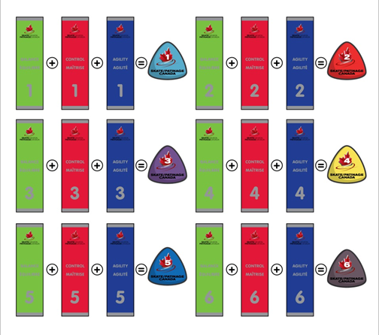
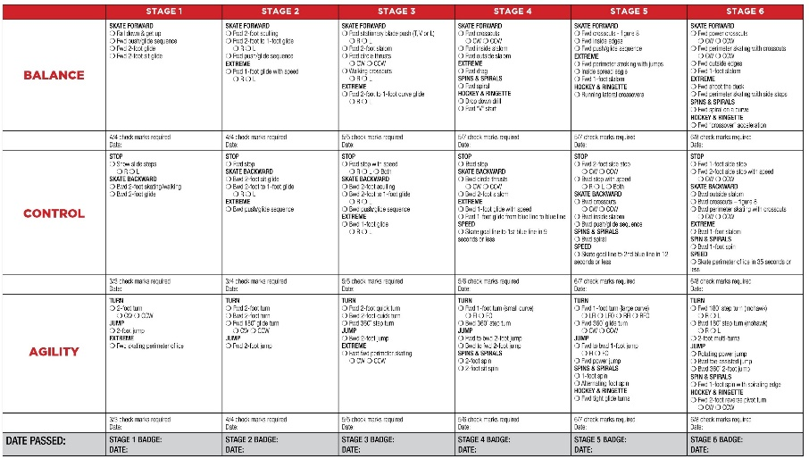
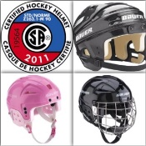
The requirement to wear a helmet is a Skate Canada Policy and all clubs and members must abide by their policies. To participate in the CanSkate program all skaters, who have not achieved Stage 6 in the CanSkate program must wear a CSA approved hockey helmet while on the ice.
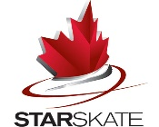
When skaters complete the 6 stages of the CanSkate program they will be eligible to move into the StarSkate program. Fast Track is a program where skaters are invited to join before completing CanSkate if the coaches feel that they have successfully achieved all the Stage 6 components.

Our Power Skating Program
CanPowerSkate is an action-packed, high energy instructional power skating program geared to hockey skaters that focuses on balance, power, agility, speed and endurance. Skills, techniques and conditioning drills are taught in a progressive format that emphasizes how the skills apply to game situations. CanPowerSkate provides an alternative to figure skating and is an excellent complement for those athletes playing on hockey teams.
For safety reasons participants, must wear full hockey equipment that is CSA approved.
To register for CanPower/Power Skating Program you must already have basic forward and backward skating skills (they must be able to skate the length of the rink using alternate strides) and can stop on command without use of the boards.
The CanPowerSkate program is exclusive to Skate Canada and is available only to Skate Canada member clubs and sanctioned skating schools. All participants must be registered with Skate Canada. Our coaching staff are all Power Skating trained.

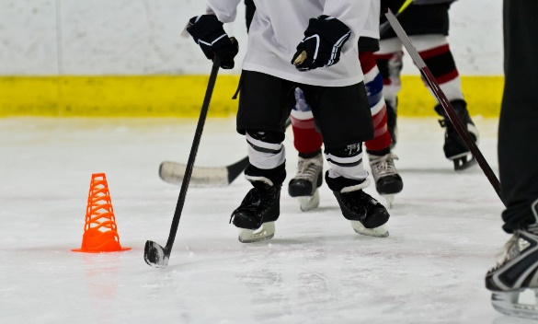

Our Power Skating Program runs
Monday 7:15 – 8:00

Volunteering
There is a $50.00 refundable volunteer fee with each skater registration. Upon completion of 2 volunteer commitments/skater your $50,00 will be returned. The following are volunteering opportunities throughout our skating season
- Independent BBQ (usually done in the summer)
- Skokie Skate - an HSC hosted skating competition in October
- Santa Skate (December)
- Carnival (April)
- Off ice Canskate door parent
- Test Days (December & March)

Fundraising
(on going throughout the season)

- Buy & Sell (bring in your used skates and skating clothing and we will sell for you. You set the price and the club keeps 20% of the sale price. This is out on display several times throughout the season for skaters and families to purchase items – CASH ONLY SALES)

- Mabels Labels – http://mabelslabels.com/ click on support a fundraiser before placing your order and select HUNTSVILLE SKATING CLUB – place you order like you regularly do and the club gets 20% of all sales.

- Boston Pizza – When you eat at Boston Pizza in Huntsville ONLY, write HUNSTVILLE SKATING CLUB on the back of your receipt and then put in the box at the front desk – the club then gets 10% of all food purchases.

- Fundscrip – http://www.fundscrip.com/ You can purchase Gift Cards for any occasion or maybe you just want to use gift cards for your weekly gas or groceries. Either way, when you place an order using our invitation code you can support The Huntsville Skating Club and raise money for yourself at the same time. 10% of each order goes to the club and HSC club members get 90% back as earned funds, that is paid out twice a year. Non-HSC members who place an order, 100% earnings will go back to the club. All you have to do is go to www.fundscrip.com and click on Support Your Group.
Then put in the invitation code: 8B7HAC
Please note: Cards will be shipped to your home via Canada Post at a charge of .85 cents plus tax with a 4-card limit/order to keep the weight down

Huntsville Skating Club

Fall & Winter Ice Schedule

2017-2018

Monday-Don Lough Arena
- 3:30 pm – Senior - Skills
- 3:45 pm – Senior – Dance
- 4:00 pm – Senior – Stroking
- 4:15 pm – Senior - Freeskate
- 5:00 pm – FLOOD
- 5:15 pm – PreCanSkate and CanSkate (Start date October 16)
-Pre-season CanSkate 4, 5, 6 & Session #1 Youth PowerSkating (13 & under) Sept 7-28
- 6:00 pm –Junior - Stroking
- 6:15 pm - Junior - Skills
- 6:30 pm – Junior - Dance
- 6:45 pm - Junior - Freeskate
- 7:15 pm – Session #2 Youth PowerSkating (13 & under) Sept 11, 18, 25, Oct 2, 16, 23 & 30
-Session #3 Youth PowerSkating (13 & under) Nov 6, 13, 20, 27, Dec 4, 11, & 18
-Session #4 Youth PowerSkating (13 & under) Jan 8, 15, 22, Feb 5, 12, 26 & Mar 19
- 8:00 pm – FLOOD
- 8:15 pm – Teen/Adult PowerSkating (13 & over) Sept 11, 18, 25, Oct 2, 16, 23 & 30
-Teen/Adult Learn to Skate & Beyond Nov 6 – Mar 26

Wednesday-Jack Bionda Arena
- 7:00 am to 8:00 am – Junior & Senior - Freeskate
Thursday-Don Lough Arena
- 4:00 pm –Junior - Freeskate
- 4:45 pm - Junior - Dance
- 5:00 pm - FLOOD
- 5:15 pm – Junior - Skills
- 5:30 pm – Junior & CanSkate 5/6 - Stroking
- 5:45 pm – PreCanSkate and CanSkate (Start date Oct 12)
-Pre-season CanSkate 4, 5, 6 & Session #1 Youth PowerSkating (13 & under) Sept 7-28
- 6:30 pm – Senior – Skills
- 6:45 pm – Senior – Dance
- 7:00 pm – Senior - Stroking
- 7:15 pm – Senior - Freeskate
Sunday-Jack Bionda Arena
- 8:00 am to 9:30 am – Junior & Senior – Freeskate

Huntsville Skating Club
P.O Box 5285
Huntsville, Ontario
P1H 2K6
www.huntsvilleskatingclub.ca
email: huntsvilleskatingclub@gmail.com

