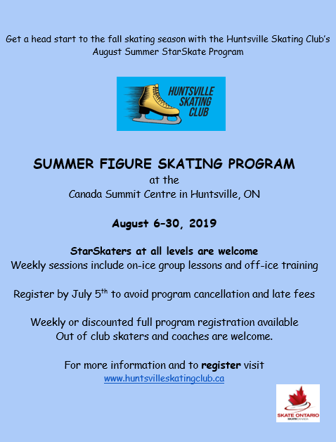

REGISTRATION FORM – 2019 SUMMER ICE

REGISTRATION
Skater’s Name:
Skater’s Birthdate:
Skate Canada#
Address:
Highest Test:
Parent’s name:
Email:
Phone Number:
Home Club:
Coach:
Coach’s email:

Parent’s Consent and Acknowledgement of Risk
I/we being fully aware of the nature and extent of injury involved in participating in skating nonetheless hereby assume such risks on behalf of my son/daughter/ward/self________________________________________________________. Also, the Huntsville Skating Club does not assume any responsibility for any injury to a parent assisting their child, so I/we give our son/daughter/ward/self-permission to participate in the skating program of the Huntsville Skating Club.

I/we and our heirs and assigns, hereby forever release, discharge and hold harmless, the Huntsville Skating Club, its directors, members, employees, volunteers, representatives and agents from any liability for any injury, loss or damage sustained by my/our son/daughter/ward/self in the practices, training, competition and other programs of the Near North Region Board, its directors, members, employees, volunteers, representatives and agents. The Huntsville Skating Club has permission to use any images or likeness for promotional or fundraising activities.
IN WITNESS WHEREOF, I/we sign this waiver on the _____________ day of ____________________________ 2019.
_____________________________Parent/Guardian/Self if over 18

REGISTRATION FORM – 2019 SUMMER ICE

 | August 5 | August 6 |  | August 7 |  |  | August 8 |  |  |  | August 9
Group A  Must have passed CanSkate  Stage 6 | No Skating | 4:00-4:45 Off-ice  5:00-5:45 Freeskate  5:45-6:15 Group |  | 5:00-5:45 Freeskate  5:45–6:15 Group |  |  | 4:00-4:45 Off-ice  5:00-5:45 Freeskate  5:45-6:15 Group |  |  |  | 5:00-5:45 Freeskate  5:45–6:15 Group
 | August 12 | August 13 |  | August 14 |  |  | August 15 |  |  |  | August 16
 | 5:00-5:45 Freeskate  5:45–6:15 Group | 4:00-4:45 Off-ice  5:00-5:45 Freeskate  5:45-6:15 Group |  | 5:00-5:45 Freeskate  5:45-6:15 Group |  |  | 4:00-4:45 Off-ice  5:00-5:45 Freeskate  5:45-6:15 Group |  |  |  | 5:00-5:45 Freeskate  5:45-6:15 Group
 | August 19 | August 20 |  | August 21 |  |  | August 22 |  |  |  | August 23
 | 3:00-3:45 Freeskate  3:45-4:15 Group | 2:00-2:45 Off-ice  3:00-3:45 Freeskate  3:45-4:15 Group |  | 3:00-3:45 Freeskate  3:45-4:15 Group |  |  | 2:00-2:45 Off-ice  3:00-3:45 Freeskate  3:45-4:15 Group |  |  |  | 3:00-3:45 Freeskate  3:45-4:15 Group
 | August 26 | August 27 |  | August 28 |  |  | August 29 |  |  |  | August 30
 | 5:00-5:45 Freeskate  5:45-6:15 Group | 4:00-4:45 Off-ice  5:00-5:45 Freeskate  5:45-6:15 Group |  | 5:00-5:45 Freeskate  5:45-6:15 Group |  |  | 4:00-4:45 Off-ice  5:00-5:45 Freeskate  5:45-6:15 Group |  |  |  | 5:00-5:45 Freeskate  5:45-6:15 Group
Group B

Must have passed 2/3 star 5 tests
 | August 5 | August 6 |  | August 7 |  |  | August 8 |  |  |  |  | August 9
 | No skating | 5:45-6:15 Group  6:15-7:00 Freeskate  7:15-8:00 Off-ice |  | 5:45-6:15 Group  6:15-7:00 Freeskate |  |  | 5:45-6:15 Group  6:15-7:00 Freeskate  7:15-8:00 Off-ice |  |  |  | 5:45-6:15 Group  6:15-7:00 Freeskate
 | August 12 | August 13 |  | August 14 |  |  | August 15 |  |  |  |  | August 16
 | 5:45-6:15 Group  6:15-7:00 Freeskate | 5:45-6:15 Group  6:15-7:00 Freeskate  7:15-8:00 Off-ice |  | 5:45-6:15 Group  6:15-7:00 Freeskate |  |  | 5:45-6:15 Group  6:15-7:00 Freeskate  7:15-8:00 Off-ice |  |  |  |  | 5:45-6:15 Group  6:15-7:00 Freeskate
 | August 19 | August 20 |  | August 21 |  |  | August 22 |  |  |  |  | August 23
 | 3:45-4:15 Group 4:15-5:00 Freeskate | 3:45-4:15 Group  4:15-5:00 Freeskate  5:15-6:00 Off-ice |  | 3:45-4:15 Group  4:15-5:00 Freeskate |  |  | 3:45-4:15 Group  4:15-5:00 Freeskate  5:15-6:00 Off-ice |  |  |  | 3:45-4:15 Group  4:15-5:00 Freeskate
 | August 26 | August 27 |  | August 28 |  |  | August 29 |  |  |  | August 30
 | 5:45-6:15 Group 6:15-7:00 Freeskate | 5:45-6:15 Group  6:15-7:00 Freeskate  7:15-8:00 Off-ice |  | 5:45-6:15 Group  6:15-7:00 Freeskate |  |  | 5:45-6:15 Group  6:15-7:00 Freeskate  7:15-8:00 Off-ice |  |  |  | 5:45-6:15 Group  6:15-7:00 Freeskate

REGISTRATION FORM – 2019 SUMMER ICE

REGISTRATION FEES:
DETAILS |  | FEE | AMOUNT OWING
Group A  Must have passed  CanSkate Stage 6 | Full Session | $550.00
 | Week 1 | $135.00
 | Week 2 | $165.00
 | Week 3 | $165.00
 | Week 4 | $165.00
Group B  Must have passed  2/3 star 5 tests | Full Session | $550.00
 | Week 1 | $135.00
 | Week 2 | $165.00
 | Week 3 | $165.00
 | Week 4 | $165.00
ADDITIONAL CHARGES: | Skate Canada Membership  (only require if you were not register with a Skate Canada club between September 2018 and March 2019) | $40.00
 | Late Fee (for registrations being sent after July 5th, 2019) | $50.00
TOTAL OWING:
PAYING BY: CASH CHEQUE E-TRANSFER
*PAYMENT MUST BE RECEIVED WITH REGISTRATION IN ORDER TO SECURE YOUR SPOT*

REGISTRATION FORM – 2019 SUMMER ICE

The Summer Figure Skating Program is run by the Huntsville Skating Club and will be held at the Canada Summit Centre at 20 Park Drive, Huntsville, Ontario on the Don Lough Ice Pad.
Full payment must be received to the Huntsville Skating Club by Friday, July 5, 2019 to avoid disappointment. Space is limited. Late registrations may be accepted, if space permits, but are subject to a late fee of $50.
Payment can be made by cheque, or e-transfer. A non-refundable $50.00 deposit is applied. NSF cheques will be subject to a $32 charge. No withdrawals after the session commencement on August 6 without a medical certificate.
Attn: Summer Ice Registration
Huntsville Skating Club
PO Box 5285 - Station Main Huntsville, ON P1H 2K6.

Please register only for the session that you are fully qualified to skate in. A minimum of skaters is required to run each session. If there are not enough registrants, sessions may be combined or cancelled. If cancelled, a full refund will be issued. Once registration is completed, you will be notified if skaters need to be moved to balance a session. Ice times may change slightly with flooding schedule.

Group lessons and off-ice sessions are included in the price.
HSC Club Coaches:
Chrissy Mantle-Marnoch 705 787-0393 | Cmskate5000@gmail.com
Linda Vandertas 705 689-5406 | lindavandertas@live.ca
Tim White 705 752-2007 | soulim2009@hotmail.com
Jeff Trott 705-645-0809 j_trott1978@yahoo.ca

Out of town skaters can select a coach from the list above or certified Skate Canada coaches from outside clubs are welcome to coach registered skaters during the sessions. All attending coaches must provide their NCCP# and proof of registration. Note that Huntsville Skating Club coaches can ask skaters and outside coaches to depart the ice if an issue arises.
Skaters are welcome to attend partial sessions, but the full weekly session registration fee still applies. Guest skating is limited two times during the 4-week period at $40 per day and available only if space permits. Please submit payment to one of our Club Coaches.
Questions about the Summer Ice Program can be sent to huntsvilleskatingclub@gmail.com.

